Tab 10
ITA0601
MACHINE LEARNING

EXP 20

Implement Future Sales Prediction using a suitable machine learning algorithm

Procedure
1. Import the Linear Regression model.
2. Create the dataset and target values.
3. Train the model using the training data.
4. Predict future sales for a new input.
5. Display the predicted result

Dataset 1: Monthly Product Sales
Advertising Budget (₹ Thousands) | Number of Salespersons | Monthly Sales (Units) [Target Variable]
20 | 2 | 100
25 | 2 | 120
30 | 3 | 150
35 | 3 | 170
40 | 4 | 200
45 | 4 | 220
50 | 5 | 250
55 | 5 | 270
60 | 6 | 300
65 | 6 | 320

New Sample Data for Prediction:
Advertising Budget (₹ Thousands) | Number of Salespersons
48 | 5

PROGRAM

import numpy as np

X=np.array([[20,2],[25,2],[30,3],[35,3],[40,4],
[45,4],[50,5],[55,5],[60,6],[65,6]],float)
y=np.array([250,290,340,390,450,510,580,640,710,780],float)

X1=np.c_[np.ones(len(X)),X]
b=np.linalg.pinv(X1.T@X1)@X1.T@y

new=np.array([1,48,5])
print("Predicted Future Sales:",round(new@b,2))

OUTPUT

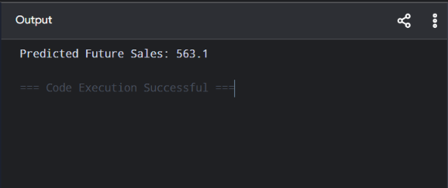

Dataset 2: Retail Store Sales
Store Area (sq.ft) | Daily Customers | Monthly Sales (₹ Lakhs) [Target Variable]
1000 | 120 | 8
1200 | 150 | 10
1400 | 180 | 12
1600 | 220 | 15
1800 | 260 | 18
2000 | 300 | 22
2200 | 340 | 26
2400 | 380 | 31
2600 | 420 | 36
2800 | 460 | 42

New Sample Data for Prediction:
Store Area (sq.ft) | Daily Customers
2100 | 320

PROGRAM

import numpy as np

X=np.array([[1000,120],[1200,150],[1400,180],[1600,220],[1800,260],
[2000,300],[2200,340],[2400,380],[2600,420],[2800,460]],float)
y=np.array([8,10,12,15,18,22,26,31,36,42],float)

X1=np.c_[np.ones(len(X)),X]
b=np.linalg.pinv(X1.T@X1)@X1.T@y

new=np.array([1,2100,320])
print("Predicted Future Sales:",round(new@b,2),"Lakhs")

OUTPUT

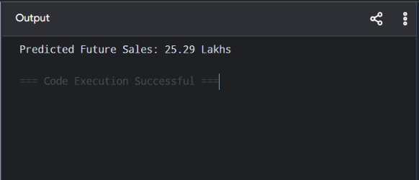

Dataset 3: Online Business Sales
Website Visitors | Advertisement Cost (₹) | Sales (Orders) [Target Variable]
1000 | 5000 | 120
1500 | 7000 | 180
2000 | 9000 | 250
2500 | 11000 | 320
3000 | 13000 | 400
3500 | 15000 | 490
4000 | 17000 | 580
4500 | 19000 | 670
5000 | 21000 | 760
5500 | 23000 | 850

New Sample Data for Prediction:
Website Visitors | Advertisement Cost (₹)
4200 | 18000

PROGRAM

import numpy as np

X=np.array([[1000,5000],[1500,7000],[2000,9000],[2500,11000],
[3000,13000],[3500,15000],[4000,17000],[4500,19000],
[5000,21000],[5500,23000]],float)
y=np.array([120,180,250,320,400,490,590,700,820,950],float)

X1=np.c_[np.ones(len(X)),X]
b=np.linalg.pinv(X1.T@X1)@X1.T@y

new=np.array([1,4200,18000])
print("Predicted Future Sales:",round(new@b,2),"Orders")

OUTPUT

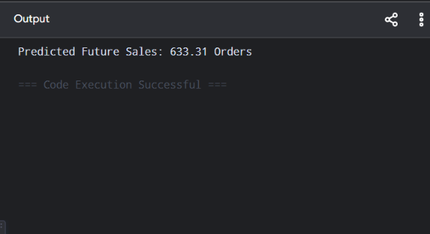

Dataset 4: Supermarket Sales Prediction
Discount (%) | Customers per Day | Weekly Sales (₹ Thousands) [Target Variable]
5 | 150 | 220
8 | 180 | 260
10 | 220 | 310
12 | 260 | 360
15 | 300 | 420
18 | 340 | 490
20 | 380 | 570
22 | 420 | 650
25 | 460 | 740
28 | 500 | 840

New Sample Data for Prediction:
Discount (%) | Customers per Day
18 | 350

PROGRAM

import numpy as np

X=np.array([[5,150],[8,180],[10,220],[12,260],[15,300],
[18,340],[20,380],[22,420],[25,460],[28,500]],float)
y=np.array([220,260,310,360,420,490,570,650,740,840],float)

X1=np.c_[np.ones(len(X)),X]
b=np.linalg.pinv(X1.T@X1)@X1.T@y

new=np.array([1,18,350])
print("Predicted Future Sales:",round(new@b,2),"Thousand")

OUTPUT

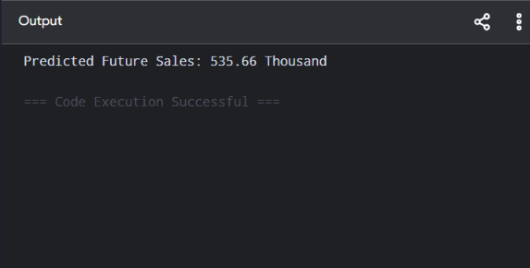

Dataset 5: Automobile Showroom Sales
Marketing Budget (₹ Thousands) | Test Drives Conducted | Cars Sold [Target Variable]
30 | 20 | 35
40 | 25 | 45
50 | 30 | 55
60 | 48 | 65
70 | 75 | 80

New Sample Data for Prediction:
Marketing Budget (₹ Thousands) | Test Drives Conducted
58 | 48

PROGRAM

import numpy as np

X=np.array([[30,8],[35,10],[40,13],[45,17],[50,22],
[55,28],[60,35],[65,40],[70,45],[75,50]],float)
y=np.array([8,10,13,17,22,28,35,40,45,50],float)

X1=np.c_[np.ones(len(X)),X]
b=np.linalg.pinv(X1.T@X1)@X1.T@y

new=np.array([1,58,30])
print("Predicted Future Sales:",round(new@b,2),"Cars")

OUTPUT

